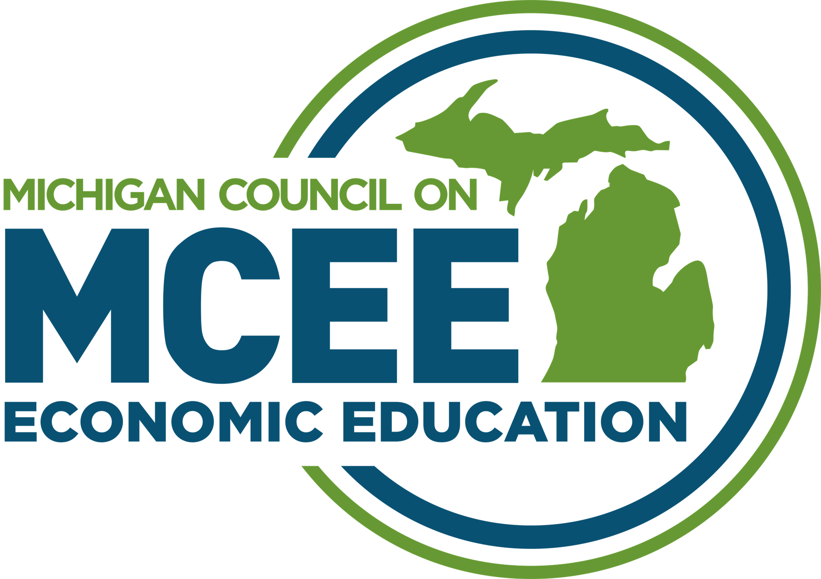

Teaching Economics in American History
Saturday, April 24th, 2021
Webinar Agenda
All Times Are Eastern Standard Time

9:00 Welcome: Michigan Council on Economic Education
Overview of the Webinar: Mark Schug

9:15 Session 1: How Can Economics Illuminate History? An Introduction to the Economic Way of Thinking (Chapter 1)
Mark Schug, Emeritus, University of Wisconsin-Milwaukee

10:15 Break

10:30 Concurrent Sessions
- Why Did the Colonists Succeed Economically without Finding Gold and Silver? (Chapter 2)
Scott Niederjohn Senior Vice President for Cooperative Education and Economic Development and Walther Kohler Professor of Economics, Lakeland University, Sheboygan, WI
Zoom Room 1
- Why Did a Mild Recession in 1929 Become the Great Depression of the 1930s? (Chapter 20)
Mark
Zoom Room 2

11:30 Overview of the Features of Economic Episodes in American History
Mark

12:00 Lunch Break

12:30 Concurrent Sessions
- Hard Currency or Cross of Gold? (Chapter 14)
Scott
Zoom Room 1

- Who Desegregated Major League Baseball: Jackie Robinson or Adam Smith? (Chapter 25)
Mark
Zoom Room 2

1:30 Great Resources for Improving the Teaching of History Using Economic Principles
Mark and Scott
- Reminders regarding how to get classroom sets of EEAH
- Final Questions

2:00 Adjourn

Meet the Presenters
M. Scott Niederjohn is Senior Vice President for Cooperative Education and Economic Development and Walter Kohler Professor of Economics at Lakeland University in Sheboygan, Wisconsin. Professor Niederjohn is also the Director of Lakeland’s Center for Economic Education. Dr. Niederjohn holds undergraduate and master’s degrees from Marquette University and a Ph.D. in economics from the University of Wisconsin–Milwaukee.
Professor Niederjohn has published more than fifty articles, monographs, reports, and curriculum materials in journals such as Applied Economics, Monthly Labor Review, Journal of Urban Affairs, Eastern Economics Journal, Journal of Private Enterprise, and Wisconsin Interest.
Professor Niederjohn’s research is concentrated in the areas of economic education, public policy analysis, and applied microeconomics. He serves on the Governor's Council for Financial Literacy and has received the Governor’s Financial Literacy Award in 2011, 2012 and 2015.
During the fall of 2013, Professor Niederjohn was awarded a Fulbright Scholarship to teach at the University of Luxembourg. He serves on the boards of the (National) Association of Private Enterprise Education and the Business. Niederjohn was recognized in the December 2014 issue of Money Magazine for his work in shaping the landscape of financial education curriculum.
Mark C. Schug is Professor Emeritus at the University of Wisconsin Milwaukee and Senior Program Advisor to the Lakeland University Office for the Advancement of Free Enterprise Education. Professor Schug taught for 36 years at the middle school, high school, and university levels. A widely-recognized scholar, he has written and edited over 230 articles, books, and national curriculum materials. Professor Schug has spoken to local, state, and national groups throughout the United States and in 11 other countries. He has been the guest co-editor of 11 issues of Social Education, the flagship journal of the National Council for the Social Studies. His latest books are Teaching Economics in Troubled Times published by Routledge Press and co-edited with William C. Wood of James Madison University and Economic Episodes in American History published by Wohl Publishing and co-authored by William C. Wood, Tawni Hunt Ferrarini and M. Scott Niederjohn, now in its second edition. The same author team of Ferrarini, Niederjohn, Schug, and Wood has written Teachers Can Be Financially Fit: Economists’ Advice for Educators which will be released in 2020 from Springer Publications.
Professor Schug does consulting for several local, state, and national organizations and has served on the boards of local, state, and national non-profit organizations including the (national) Association of Private Enterprise Education, Economics Wisconsin, Business and Economics Academy of Milwaukee (BEAM), School Choice Wisconsin, and the Wisconsin Council for the Social Studies. Professor Schug earned his Ph.D. from the University of Minnesota. He has received six national awards for leadership, curriculum writing (two), service, and research (two) in economic education.
Mark and his wife Io have been married for 52 years, have two grown daughters, and four grandchildren. They live in Port St. Lucie, Florida.

